3.Write the python program for water jug problem

AIM:
To write a Python program to solve the Water Jug problem using state-space search in Artificial Intelligence.
Objective:
To obtain the required amount of water by performing valid operations on two water jugs.
Algorithm:
1. Start.
2. Define the capacities of the two jugs.
3. Fill, empty, or pour water between the jugs.
4. Check whether the required amount of water is obtained.
5. If the goal is reached, display the steps.
6. Otherwise, repeat the operations.
7. Stop.
Flowchart:
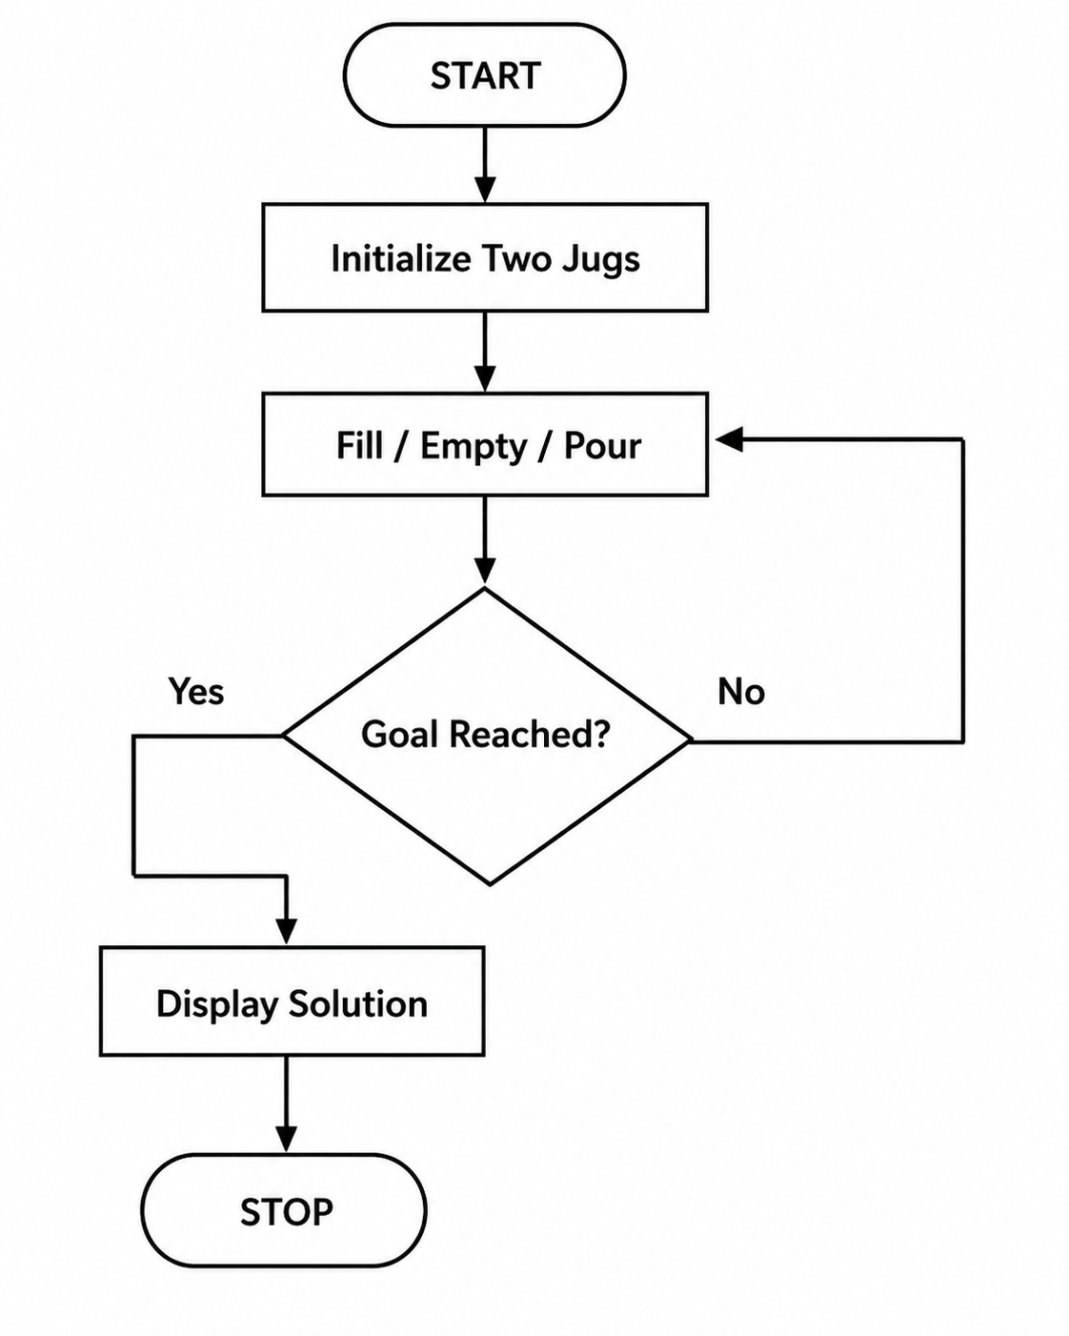

Code:
jug1 = 4
jug2 = 3
goal = 2

x = 0
y = 0

print((x, y))

x = jug1
print((x, y))

y = jug2
x = x - (jug2 - y)
print((1, 3))

y = 0
print((1, 0))

y = 1
x = 0
print((0, 1))

x = jug1
print((4, 1))

y = 3
x = 2
print((2, 3))

y = 0
print((2, 0))

print("Goal Reached")

OUTPUT:
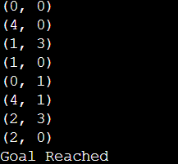

RESULT:
The Python program successfully obtained 2 liters of water using the 4-liter and 3-liter jugs.

CONCLUSION:
The Water Jug problem was successfully solved using valid fill, empty, and pour operations. The program reached the desired goal state, demonstrating the application of state-space search concepts in Artificial Intelligence.

